**COURSEWORK SUBMISSION FORM**

|  |  |  |  |
| --- | --- | --- | --- |
| **STUDENT USE** | | **STAFF USE** | |
| Module Name | Developing Digital Enterprise | First Marker’s  (acts as signature) |  |
| Module Code | **6COSC013C-n** | Second Marker’s  (acts as signature) |  |
| Lecturer Name | Jakhongir Karimov | Agreed Mark |  |
| UoW Student IDs |  | **For Registrar’s office use only (hard copy submission)** | |
| WIUT Student IDs | 00010023 |
| Deadline Date | 24.10.2022 |
| Assignment Type | Individual |
| Word Count | 1840 |

**SUBMISSION INSTRUCTIONS**

**COURSEWORKS *must* be submitted in *both* HARD COPY (to the Registrar’s Office) *and* ELECTRONIC unless instructed otherwise.**

For hardcopy submission instructions refer to: <http://intranet.wiut.uz/Shared%20Documents/Forms/AllItems.aspx> - Coursework hard copy submission instructions.doc

For online submission instructions refer to: <http://intranet.wiut.uz/Shared%20Documents/Forms/AllItems.aspx> - Coursework online submission instructions.doc

|  |
| --- |
| **MARKERS FEEDBACK (Continued on the next page)** |
|  |

**Table of Contents**

Executive Summary 2

Business Process Model 3

IT Architecture Model 5

Legal Considerations and Risk Management Plan 6

Digital Project Implementation Plan 9

Reference List 11

**Executive Summary**

Online food ordering systems’ business process model could be improved by addressing customer-oriented issues, such as their waiting time. This could be solved by introducing a computer which is called food automation process. IT architecture model of my digital business would remain quite simple, yet it would allow to store food orders both to staff members’ computers as well as databases. License validation, intellectual property and privacy intrusion would be the main legal aspects to consider, whereas the risks would consist of delivery issue, hacking, bad publicity, blackout and server fall. To achieve success in running the online food ordering system, digital project implementation plan will be divided into four main phases. These include discovery, content, design and development stages.

**Business Process Model**

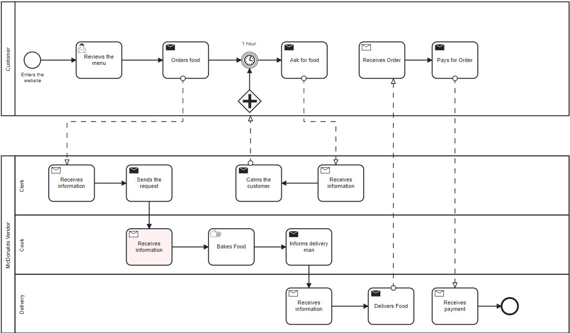

Business process model in online food ordering could be similar to a number of other restaurants’ systems where the main external participants can be customers and the restaurant vendors consisting of internal pools, namely clerk, cook and delivery man. After entering the website, a client reviews the menu and places an order. The order is then received by the clerk, who in turn send the task to a cook to prepare food. Once food has been cooked, delivery man receives the order from the cook and delivers the order. Delivery man, thereafter, receives payment and returns to work. However, in case a client has been waiting for the order for more than 1 hour, he/she gets in touch with the clerk, who has no choice but to calm the customer. The problem with this typical business process model is that the customer has no information regarding the process and timing of food preparation. For this reason, let us analyze a potential solution to the problem arising from this business process model.

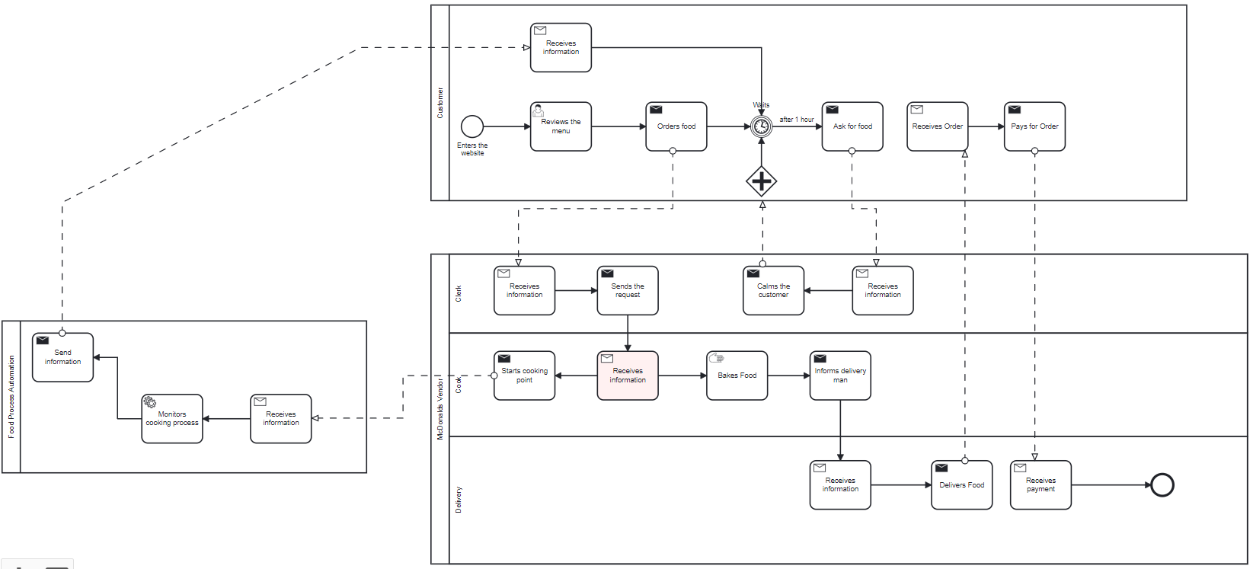

This new business process model, by contrast, incorporates an ICT solution to tackle customer expectation while waiting for food preparation. The idea is to develop a technology or computer that would calculate the percentage of food being cooked, which would be called food process automation. Once a cook receives the order from the clerk, he/she then will need to click certain button, for example, to send a message to the integrated computer to start monitoring food preparation process. The computer, then, using algorithms will be constantly updating a client regarding the order. The main advantage of introducing food process automation lies in customer relationship handling. In other words, even if the customer waits for more than an hour, he/she will be aware of food preparation process. Less customers will then distract the clerk asking about the order. Yet, the monitoring system cannot be launched without manual work if, for instance, a cook does not send the task to initiate the calculation which is the main disadvantage of this business process model. This means that cooks will constantly need to click a certain button upon receiving each order to send the request to monitor food preparation.

**IT Architecture Model**

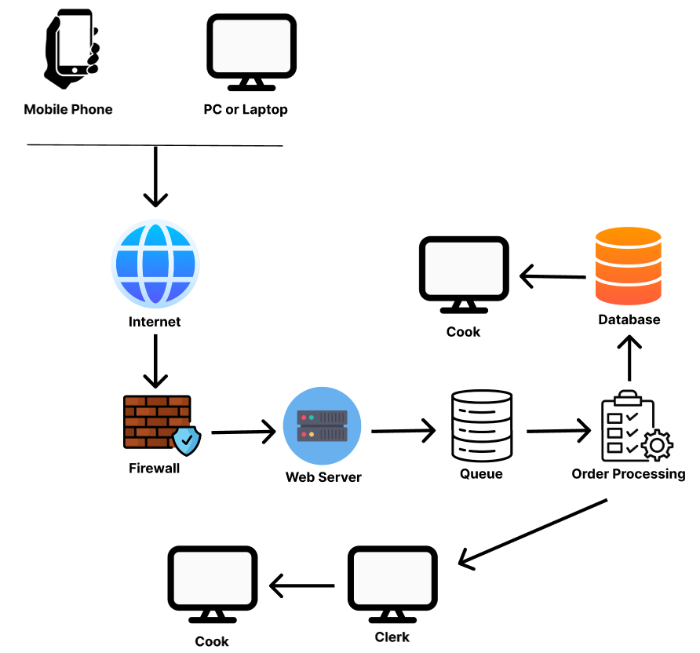

IT architecture model in my food industry will be quite simple which would allow better optimization.

A client will enter the website by using both mobile phone and computer (laptop). The request will be verified by firewall for security purposes. Once the order reached the web server, it will automatically be queued which will launch order processing. The order is then inputted into database from which, cooks can receive information. Besides, order processing will inform the clerk separately from database. This is where IT architecture shows its benefits. Order processing accesses both the database and computers of staff member to ensure that a cook does not miss an order. In case of database damage, staff members will still have access to the orders processed. The primary drawback of this IT architecture model, however, could be related to the absence of cloud-based system which could ensure better security of data. Yet, the integration of cloud servers could prove resourceful for a typical food restaurant, which is the reason this aspect has been undermined.

**Legal Considerations and Risk Management Plan**

When it comes to legal considerations, there are, in general, three focal issues my digital project will need to address: License Validation, Intellectual Property and Privacy Protection

* **License Validation**

Launching an online food delivery system without considering license acquisition could result in in severe legal issues. According to Food Safety and Standards Act (FSSA), all food business owners and participants must be either registered or licensed under FSSA (Verma, 2006). Although this act may not be related to our country, similar acts exist in Uzbekistan which regulate legal food business activities. To be more concise, it would be important to ensure that all employees, including delivery man, are licensed to work within a company to avoid legal problems.

* **Intellectual Property**

Intellectual property in online food ordering can mostly be related to consideration of copyright issues. Considering critical acclaims, commercial success or television program success in competitive cooking, the rivalry among chefs has always remained intense (Broussard, 2008). Even though it is highly unlikely that a vigorous competition among cooks exists in Uzbekistan, their cooking methods should be protected instead of getting spread. It is, therefore, necessary to implement a plan which ensures that there is strong copyright protection for chefs, for example.

* **Privacy Protection**

The final legal consideration should concern privacy or data protection of those who utilize applications or websites to order food. This is mandatory to consider since customers share a great amount of personal information, including name, phone number, address and sometimes card number. Private information sharing has the chance to harm people even if no damaging data has been collected (Rev, 2017). To ensure that my applications are safe to order food, I could consider improving them. For example, instead of relying on social media bots to order food via mobile phone, it is possible to introduce a safer mobile application with login and password system.

Apart from legal aspects, there could also be some arising risks which will need to be taken into account. These risks in online food ordering might include delivery issues, DDoS attacks, bad publicity, blackout and server fall.

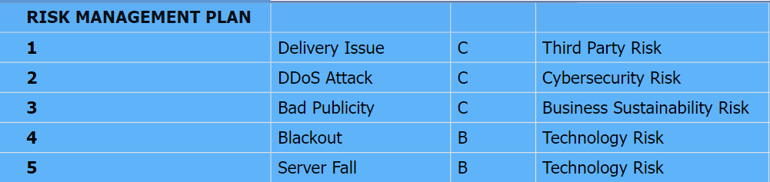

One of the main popular risks is related to third-party risks which is delivery problem. After food has been prepared and packed, there is a chance that delivery is not successful in case of car accident, for example. The risk priority is that it would need to be considered. Although the probability of occurrence could be low, the company can witness some dagame related to health of employees. In such cases, company will need to adopt to the situation and wait for better health conditions of a delivery man.

Hacking or malicious attacks should also be considered, even if there’s a firewall integrated. In case some hackers steal data and use it for their malicious purposes, the company will need to transfer the issue to the website provider with which legal contract must have been signed in the beginning. Yet, although the damage could be high, the probability of occurrence would remain low.

Another risk to be considered is bad publicity which means the negative influence on the reputation of the company. This could be related to business sustainability risks, as there would always be some clients regularly complaining about the services. Even though the level of damage and severity would be low, the probability of occurrence is frequent. Such problems would need to be mitigated by training employees to express better relations with customer or by enhancing services.

A company can also experience some data loss caused by black out, which is a technology risk. Blackout in this context means the electricity going down. As the probability of occurrence is low, this issue would simply need to be considered and adopted to wait for better conditions.

The last but not the least significant risk to consider is server fall. There could be situations where web or mobile applications stop working for some reasons. This matter will need regular attention as there could be around 10% of level of damage and severity. This risk, however, could be mitigated by enforcing frequent control over technology sustainability.

**Digital Project Implementation Plan**

Digital project implementation plan will be divided into 4 main phases: Discovery, Content, Design and Development. Here is the short view of the phases with their implementation durations throughout a year.

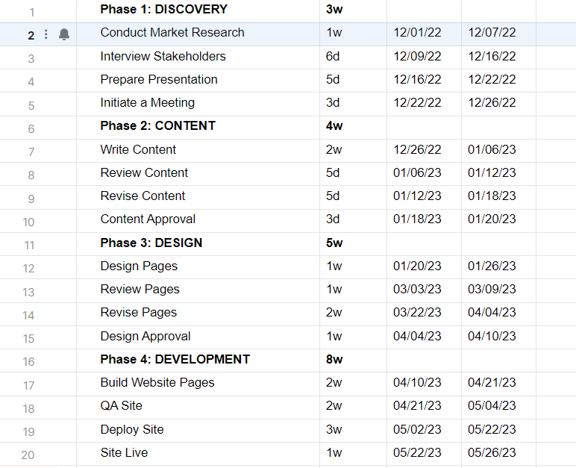

* **Phase 1: Discovery**

The first phase is the phase of analysis consisting of its four sub-parts. To begin with, market research must be conducted to find out more about local competitors and digital scope. Going through stakeholder interviews could also help find out different details and nuances in launching online food ordering system. Having gathered all need information, it would a good idea to prepare a presentation and organize a meeting to discuss some aspects of the project implementation. This would ensure that different aspects of the project are concerned, such as legal ones.

* **Phase 2: Content**

The next step is content-related. Online food ordering system needs its business idea, which will need to be written after by applying all information gathered in Phase 1. The content will then need to be reviewed to check for suitability and thoroughly revised. Once the business idea has been fully prepared, it will then need to be approved to go on with technological aspects.

* **Phase 3: Design**

This phase is of modeling aspect where certain designs should be introduced. For example, the way the web or mobile application of food ordering will look. All necessary pages will need to be designed, reviewed, and revised. After each parameter has been designed, I would need design approval which could take up to a week.

* **Phase 4: Development**

Finally, after getting approval on putting design into practice, I will sign a legal contract with the third-party company which will account for building website pages. Then, the website will be checked for Quality Assurance (QA). In other words, it will be test for potential errors, freezes and bugs. Once the website has been successfully verified, it will be hosted and ready to use.

Overall, the main advantage of dividing the digital implementation plan into four phases lies in “create-review-revise” method. Once something has been created, it is then carefully checked for potential issues and the revised, which means corrected or tested. This method would certainly help to achieve faster results in developing online food ordering system.

**Reference List**

Broussard, J. (2008). An Intellectual Property Food Fight: Why Copyright Law Should Embrace Culinary Innovation. *Vanderbilt Journal of Entertainment and Technology Law*. Available from <https://scholarship.law.vanderbilt.edu/cgi/viewcontent.cgi?article=1372&context=jetlaw> [Accessed 30 November, 2022]

Konnoth, J. (2017). An Expressive Theory of Privacy Intrusions. Available from <https://ilr.law.uiowa.edu/print/volume-102/an-expressive-theory-of-privacy-intrusions/> [Accessed 1 December 2022]

Verma, A. (2006) Legal Issues Relating to Online Food Delivery with Special Reference to “FOOD SAFETY AND STANDARDS ACT, 2006”. Available from <https://amity.edu/UserFiles/aibs/884dArticle-VI%20(Page%2038-40).pdf> [Accessed 29 November, 2022]